PamGene Report Supplement

(Generic example)
July 01, 2024
Table of Contents
1. Introduction 2
1.1. PamChip Technology and Assay Principle 2
2. Data Analysis 4
2.1. Data Analysis Overview 4
2.2. Basic Processing 5
2.2.1. Image Analysis and Signal Integration 5
2.2.2. Quality Control 5
2.2.3. Normalizations 6
2.2.4. Visual assessment of overall signal 7
2.3. Phosphosite analysis 8
2.3.1. Differential statistical analysis methods: “Test condition(s)” versus “Control” 8
2.3.2. MTvC Results 9
2.4. Kinase Analysis 10
2.4.1. Differential upstream kinase analysis methods: “Test condition(s)” versus “Control” 10
2.4.2. Kinase Analysis Results 12
3. Report information Table 14
4. Biological interpretation 15
5. Suggestions for validating results 16
6. References 16

Introduction
This supplement gives a detailed explanation of the methods used in the main study report.
With PamGene’s kinase activity profiling platform, the activity of kinases in a wide range of cells and tissues can be measured in real time. We use our proprietary 3D peptide microarray technology (PamChip® and PamStation®) which offers a multiplex method for global kinase activity profiling. The assay is very sensitive, requiring only a small amount of lysate to measure the activity of kinases in various samples including cell lines, xenografts and human tissues. Lysates obtained from a few thousand cells can suffice to obtain a kinome profile of the multiple kinases present in these samples. This is accomplished by incubating the sample lysates across peptide substrates immobilized on the 3D surface of the PamChip® microarray (196 protein tyrosine kinase (PTK) or 144 serine/threonine kinase (STK), hereafter referred to as phosphosites). Kinases present in the lysates will phosphorylate the phosphosites, which are visualized using fluorescently labelled antibodies.

PamChip Technology and Assay Principle
PamGene’s microarray assay for kinase activity profiling is based on measuring phosphorylation of phosphosites by protein kinases. The PamChip® 4 consumable consists of 4 identical arrays, each array containing 144 (STK) or 196 (PTK) phosphosites immobilized on a porous ceramic membrane (Figure 1). These phosphosites are encoded in 13 amino acid long peptides which derived from literature or computational predictions. with the phosphorylation of these phosphosites is then used to predict one or multiple upstream kinases (Protein tyrosine kinases for the PTK PamChip® and Serine threonine kinases for the STK PamChip®). Fluorescently labelled anti-phospho-antibodies are used to detect phosphorylation activity of kinases present in the sample (Figure 1).
During the assay, the sample is pumped through the porous membrane, allowing for shorter assay times. When the solution is underneath the array, images of each array are taken at several exposure times by a camera in the workstation (Figure 1). Images are later used by the BioNavigator® software to calculate signal values for each phosphosite. The data workflow consisting of image quantification, quality control, statistical analysis, visualization and interpretation is performed using the BioNavigator® software.
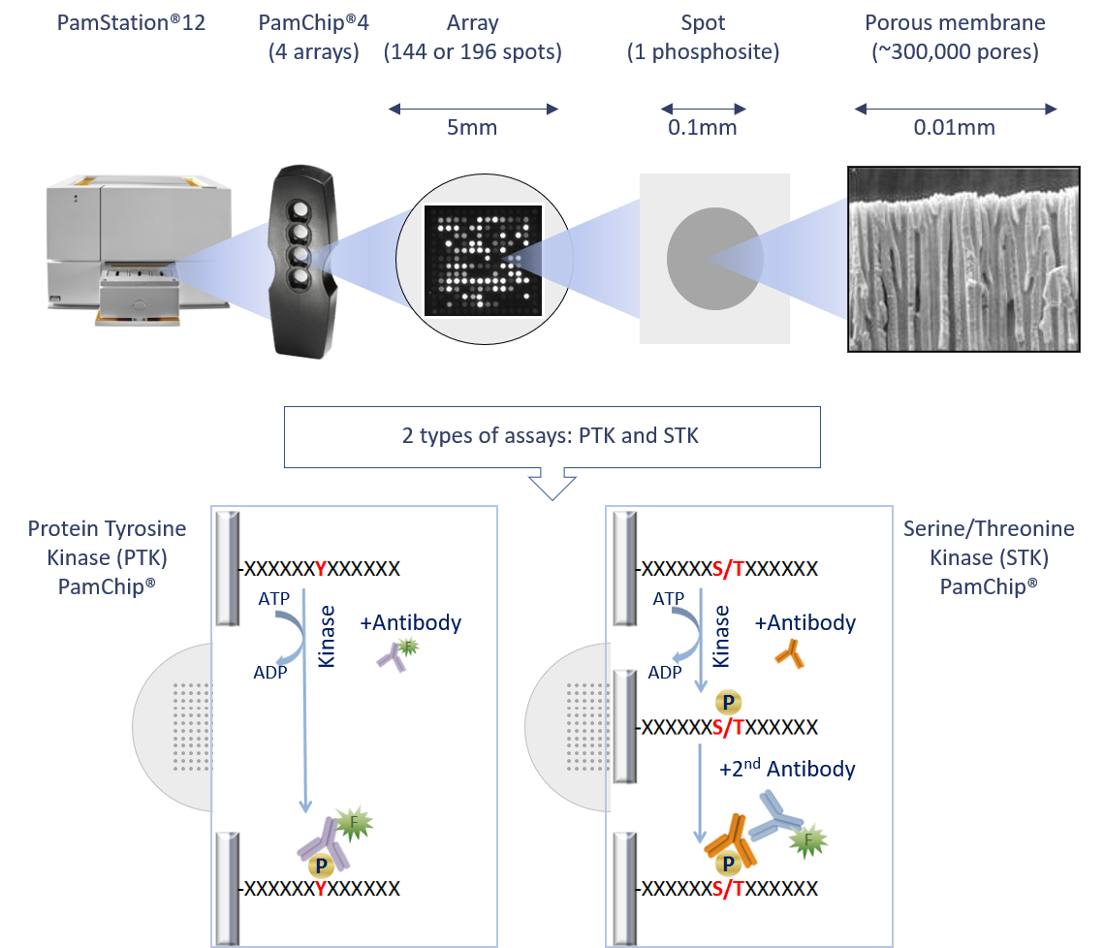
Figure 1: PamGene technology outline and PamChip assay principle.

Data Analysis

Data Analysis Overview
The general workflow for data analysis is shown below (Figure 2), which was used to derive the results described in the Report and this Supplement, with details following.
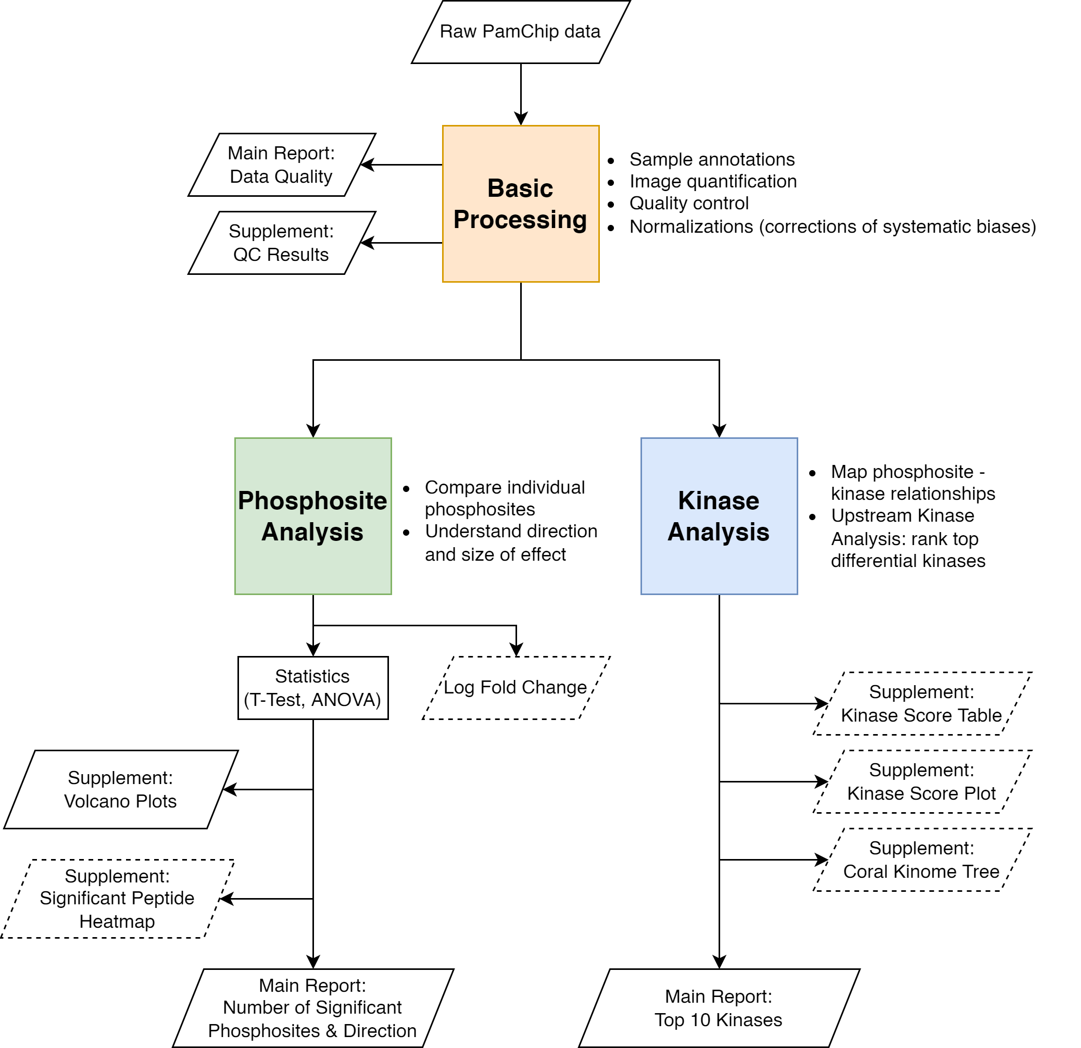
Figure 2: Data analysis workflow. Parallelograms indicate in- and outputs. Dashed lines indicate optional outputs. Basic Processing (orange box) refers to Section 2.2 of this supplement. Phosphosite Analysis (green box) refers to Section 2.3. Kinase Analysis (blue box) refers to Section 2.4. The output of Phosphosite Analysis and Kinase Analysis can be used for further biological interpretation (see also Section 2.5).

Basic Processing

Image Analysis and Signal Integration
Image Analysis
Image analysis is performed on each image. Once a grid is constructed for the image, various values (quantitation types) are calculated. The main value considered as the “signal” is called the Median_SigmBg (median signal minus background). Signal_Saturation (fraction of saturated pixels) values are used to remove saturated spots during signal integration.
Exposure Time Integration
Low exposure times are useful to capture high intensity signals, and likewise high exposure times are useful to capture low intensity signals. Therefore, the same image is acquired at multiple exposure times, and then Median_SigmBg values are integrated to a single value, called the S100 signal. Since saturated spots (5% saturation) are excluded in the integration, the dynamic range of the measurements is increased (the ratio of the highest and lowest signal that can be measured).

Quality Control
The quality of the data was assessed using criteria shown in Table 1. The QC results for the data in this study are shown in Table 2.
Three criteria were checked using a flag system is used to indicate a quality level:
- Phosphosite signal strength (i.e., the 99th percentile of S100 AU (arbitrary units).
- Phosphosite number control (i.e., how many phosphosites passed quality control).
- Sample quality control (i.e., Replicate CV (coefficient of variance); An example of technical replicate is 1 sample lysate on 3+ arrays; An example of biological replicate is 1 sample lysate per array).
Table 1: Flag system used to assess data quality
Level | Flag¹ | Signal Strength (AU) | QC-passed phosphosites (PTK) of 195 | QC-passed phosphosites (STK) of 142 | Technical CV | Biological CV
Good |  | 0-4,000 | > 123 | > 90 | < 20% | < 30%
Fair |  | 0-2,000 | 78 - 123 | 56 - 90 | 20% - 30% | 30% - 40%
Poor |  | 0-1,000 | < 78 | < 56 | > 30% | > 40%
¹The QC flag is based on the 3 individual criteria. All criteria must be met to get a green QC flag.
Number of QC-passed phosphosites (PTK)
For the PTK Assay there is a kinetic readout, with images obtained every 5 minutes during the assay. The phosphorylation kinetics for each phosphosite (each spot) is analyzed by plotting S100 values versus the Time (cycles, in minutes). Only phosphosites that show kinetics (increase of signal in time) on at least 25 % of the arrays are included in the downstream analysis (kinetic fraction present > 0.25).

Number of QC-passed phosphosites (STK)
Phosphosite QC selection for the STK assay is performed by carrying out a nominal CV estimation. Phosphosites with a CV lower than 50% over all measured arrays are included in the downstream analysis. Values after wash (Cycle 124; for the QC phosphosites) are log2 transformed and values below 0 are removed.
Table 2: QC Results
Assay Type | Flag | Signal Strength (AU) | QC passed phosphosites | Technical CV | Biological CV
PTK |  | 8,560 | 156 / 195 | n.a. | 12-28%
STK |  | 6,020 | 112 / 142 | n.a. | 15-26%
QC Notes
(Remarks if any)
See heatmaps

Normalizations
In this study, the following normalizations have been applied:
- Variance Stabilizing Normalization (VSN) (Not applied)
- ComBat Correction (Applied)
VSN 1 In log transformed data, variance increases with decreasing signal mean. This means that a certain log fold change is more significant for high-signal phosphosites (with lower variance) than for low-signal phosphosites (high variance). VSN counteracts this effect by rendering the variance independent of the mean thereby facilitating the discovery of significant phosphosites with low signal intensities. Another advantage is that VSN allows for the comparison of large numbers of samples especially from multiple PamStation runs or human samples. VSN normalization has two steps. The first step is an affine transformation which results in a shift of the y-axis to the data mean. The key outcome is that when comparing VSN-normalized samples among groups, it reveals the relative difference compared to the mean of all samples, not the absolute difference. For example, for a sample with an overall higher kinase activity compared to the control, VSN normalization results in kinases with both higher and lower activity compared to the data average. Thus the analysis highlights kinases with a higher contribution to the overall higher (or lower) kinase activity trend. The second step of VSN is equivalent to log transformation.
ComBat correction^{2,3} is a batch effect correction method. Batch effects are systematic technical effects due to the variabilities in time, place, and materials. These effects can reduce the accuracy of the results, thus they have to be counteracted. ComBat corrects for systematic biases (e.g., differences between PamStation runs, PamChips or replicates). ComBat correction is equivalent to Z-score scaling per batch but the scaling parameters (mean / sd) are estimated using an empirical Bayes approach which effectively reduces the noise associated with applying the correction.

Visual assessment of overall signal
The basic processing steps as described above result in log2-transformed or VSN-normalized values (with or without ComBat) for each peptide (rows) and each array (columns). The heatmap(s) below provide an overview of samples and measurements. This view helps to indicate possible trends and outliers. Signals before normalization are provided separately and signals after normalization are shown below.
Heatmap Overview – PTK
(Generic)
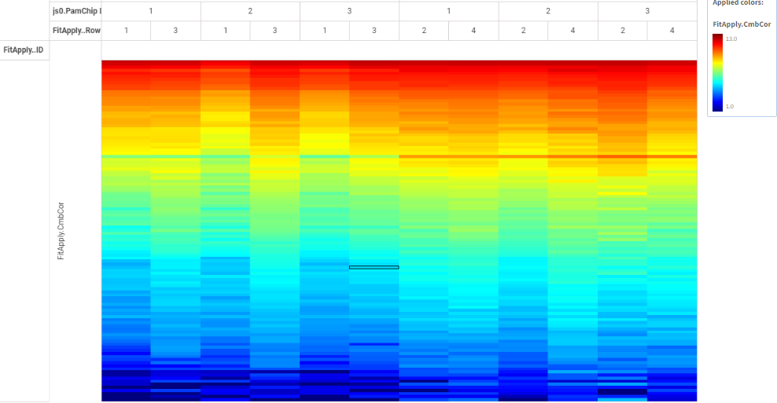

The heatmap shows Log2-values of the integrated signal after normalization. Each row is a phosphosite and each column is a PamChip array. Rows are sorted by row mean and only include phosphosites which passed the QC.
Heatmap Overview – STK

The heatmap shows Log2-values of the integrated signal. Each row is a phosphosite and each column is a PamChip array. Rows are sorted by row mean and only include phosphosites which passed the QC.

Phosphosite analysis

Differential statistical analysis methods: “Test condition(s)” versus “Control”
To identify significant differences between the conditions at the phosphosite level, the following statistical tests are used:
- Multiple Test conditions versus Control (MTvC): To compare 2 or more Test Conditions versus Control. An ANOVA is performed for significant effects anywhere between the Test Conditions (including control). A Dunnett’s post-hoc test is then performed for multiple comparisons to find significant effects between each Test Condition.
The following plot(s) show the results from the statistical tests:
- Volcano plot, useful for an overview of the Test condition vs control. Volcano plots visualize the significance (y-axis, -log10(p value)) versus the effect size (x-axis, LFC or delta) of each test. Red dots are phosphosites that show significant difference compared to control (p<0.05, i.e. -log10(p)>1.3).
- Significant phosphosites (LFC or Scaled heatmaps) – provided separately.
Results from the above tests are provided in Excel-readable format. The phosphosite level statistical tests (MTvC and/ T-test) results in LFC and p-values for each Peptide ID or sequence. Each sequence can have a 90 to 100% similarity match (using BLAST) with 1 or more UniPROT proteins. Therefore the Report results folder contains additional [*_enriched.csv] files that are enriched with Sequence, UniPROT and Gene name. This is useful for biological interpretation or pathway and network analyses. The LFC and p-values are the same for each unique Peptide ID across the different UniPROT matches.

MTvC Results
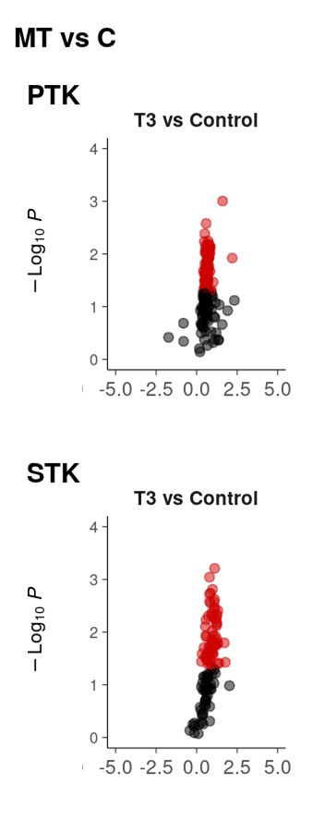
Figure 3: MTvC Volcano Plots MT vs C

Figure 4: MTvC Volcano Plots MT vs T1

Figure 5: MTvC Volcano Plots MT vs T2

Kinase Analysis

Differential upstream kinase analysis methods: “Test condition(s)” versus “Control”
The Upstream Kinase Analysis (UKA) algorithm predicts differential kinase activity in a Test Condition compared to Control. The UKA is a functional class scoring method: to predict a kinase, it analyzes the changes in its set of phosphosites. A phosphosite set of a kinase comes from public databases of kinase-protein-phosphosite relationships. The UKA assigns scores to the predicted kinases indicating how strongly the kinase is associated with the observed changes in peptide signal. UKA is run on all QC-passed peptides, not only on significant peptides. The results can be used to generate hypotheses and the selected kinases need to be further validated. Whether they make sense in a biological context is dependent on several factors (e.g., the model system used in the experiments) and requires further consideration.
The UKA algorithm returns the following scores:
- Kinase Statistic: represents the direction of effect: the change in kinase activity in a Test condition (T) compared to a Control condition (C). < 0 means inhibition, > 0 means activation in T versus C. The Kinase Statistic is the median of the Peptide Statistics of the set of peptides that a kinase can phosphorylate. The Peptide Statistic is the signal-to-noise ratio of peptides between T and C. Thus, the Kinase Statistic represents the log fold change scaled by the noise.
- Significance Score: the significance of the Kinase Statistic is based on a permutation test where the samples are permuted. The Kinase Statistic is recalculated for each permutation. The Significance Score is based on the difference between the Kinase Statistic of the actual sample versus that of the permuted samples. A high Significance Score means a high probability that the kinase is differentially active between Test and Control.
- Specificity Score: the specificity of the Kinase Statistic is based on a permutation test, where the peptides are permuted. The Kinase Statistic is recalculated for each permutation. The Specificity Score is based on the difference between the Kinase Statistic of the actual sample versus that of the permuted samples. A high Specificity Score means a high probability that the observed effect could not have been obtained by a random set of peptides.
- Kinase Score (Median Final Score): the sum of the Significance Score and the Specificity Score. Kinases are ordered by this score.
The UKA algorithm generates the following plots:
- Kinase Score Table, useful to identify the top kinases. The Score Table shows the top 10 kinases regardless of the Kinase Scores.
- Kinase Score Plot, useful to identify the effect size and direction of the top 20 kinases. Plots are colored by Specificity Score or kinase family. When a kinase family is represented by only 1 kinase from the Top 20 list, the bars are coloured grey. The Score Plots show the top 20 kinases, regardless of the Kinase Scores.
- Kinome Tree, useful to group the kinases into phylogenetic families. The Coral Trees show all kinases above the default threshold (Kinase Score > 1.3). You can also generate and fine tune your own Coral Trees here.
Results are provided as Excel (csv) files (Data tables/UKA_PTK or UKA_STK). The column Median Final Score (= Kinase Score) is used for the ranking, thus enabling selection of kinases above the default threshold (Kinase Score > 1.3). For more details of this algorithm refer to: https://pamgene.com/ps12/.
A general guideline below can be used to infer biological interpretation from the UKA results. PamGene can support and discuss these approaches.
- Use the UKA tool to give a ranked predicted list of kinases
- Select top kinase(s) based on:
  - Ranking order
  - Threshold cut-off (subjective; guideline is to use Median Final score > 1.3)
  - Known biological information
- Further validate the selected kinase based on:
  - Biological context inferred from current knowledgebase and literature
  - Other platforms and technologies
More details of this algorithm are available on request. Results are provided as Excel (txt) files.

Kinase Analysis Results

Kinase Score Plot (family) - MT - T3 vs C
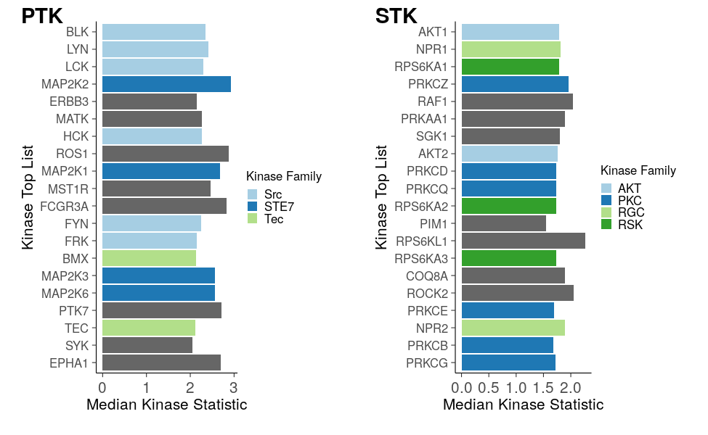
Kinase Score Plot (specificity) - MT - T3 vs C
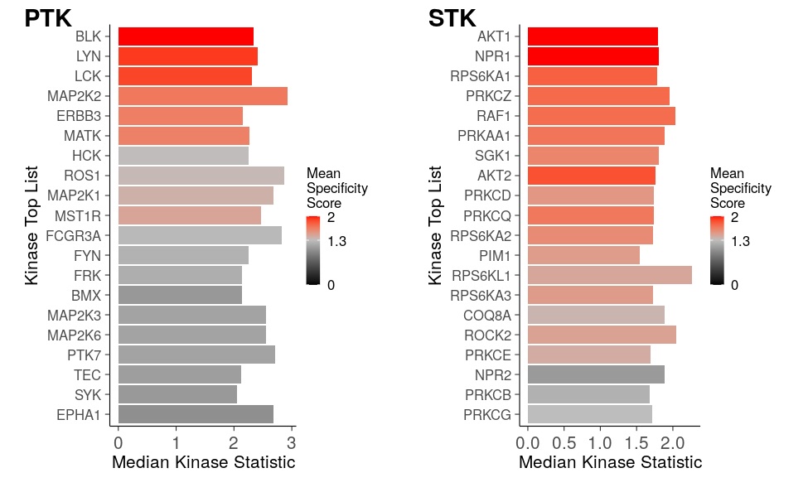

Table 3: Kinase Score Table MT - T3 vs C
 | PTK |  |  | STK
Rank | Kinase Name | Kinase Score | Kinase Statistic | Kinase Name | Kinase Score | Kinase Statistic
1 | BLK | 3.67 | 2.34 | AKT1 | 3.36 | 1.79
2 | LYN | 2.71 | 2.41 | NPR1 | 3.19 | 1.81
3 | LCK | 2.67 | 2.31 | RPS6KA1 | 2.97 | 1.79
4 | MAP2K2 | 2.67 | 2.93 | PRKCZ | 2.76 | 1.96
5 | ERBB3 | 2.62 | 2.15 | RAF1 | 2.71 | 2.04
6 | MATK | 2.55 | 2.26 | PRKAA1 | 2.67 | 1.89
7 | HCK | 2.46 | 2.26 | SGK1 | 2.62 | 1.80
8 | ROS1 | 2.45 | 2.87 | AKT2 | 2.59 | 1.76
9 | MAP2K1 | 2.34 | 2.68 | PRKCD | 2.55 | 1.74
10 | MST1R | 2.32 | 2.47 | PRKCQ | 2.55 | 1.74
Kinase Coral Tree - MT - T3 vs C
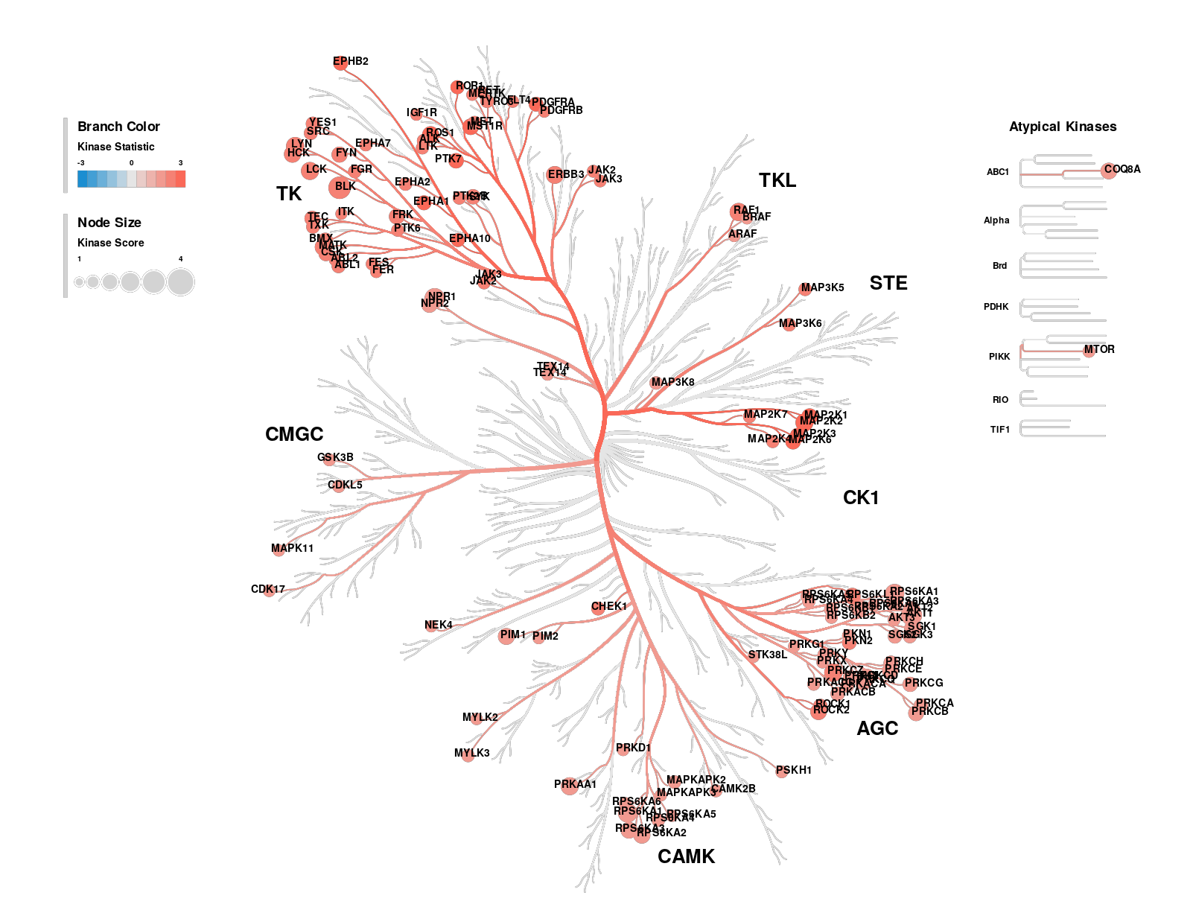

Report information Table

Deliverable | Top peptides modulated in your comparison(s) | Top kinases modulated in your comparison(s)
Where can you find the Excel table and which files are these? | - Folder called DATA FILES  - File names starting with TT (=T-Test) or MTvC (Anova-Dunnett test).  - Each Comparison is one below the other in the same file.  - Separate for PTK and STK results.  - See Supplement | - Folder called DATA FILES  - File names starting with UKA (=Upstream Kinase Analysis).  - Each Comparison is a separate Table.  - Separate for PTK and STK results.  - See Supplement
What’s reported in Main Report | - See Supplement Figure 2.  - Number of peptides that are phosphorylated up or down in Test vs Control  - Significant peptides (p-value <0.05) | - See Supplement Figure 2.  - Top 10 predicted kinases whose activity is modulated up or down in Test vs Control  - Significant kinases (Median Final score> 1.3) are further listed in separate Tables
What’s reported in Supplement | - See Supplement Figure 2.  - Volcano plots | - See Supplement Figure 2.  - Bar plots of Top 20 kinases regardless of cut-off, coloured by family and specificity scores  - Tables of Top 10 kinases regardless of cut-off  - Coral kinome trees of all kinases that pass threshold
What’s provided separately in corresponding folders | - All figures in Report  - Visual Figures like heatmaps  - Ratio maps of significant peptides  - Volcano plots | - All figures in Report
Additional information | - QC assessment, about signal strength, number of QC-pass phosphosites, replicate CV; if any, normalizations | - Upon request, and confidential clause, not for distribution:  - Filtered UKA Db (Database) list linking PamChip Peptides to Kinases form 6 Dbs. that can phosphorylate them  - This gives Peptide to kinase or Kinase to Peptide extrapolations
Additional information for data mining and interpretation | - See Supplement end for 2 Sections, for biological interpretation and Results validation  - Links to FREE tools for pathways and to help data mining

Biological interpretation
For biological interpretation, the following pathway or network analysis tools could be useful to explore. Refer to the Results Data Tables provided separately. For a specific comparison you can use: 1. Phosphosite level data: we suggest to combine the PTK and STK significant results from the TT or MTvC. Use the proteins mapped to phosphosites (in the “_enriched” files). Since multiple phosphosites can map to one protein, we suggest to use the mean. (Significant phosphosites: p value<0.05; or set your own more/ less stringent cut-off). Effect direction and size: Use LFC / delta.
- Kinase level data: We suggest to combine the UKA_PTK and UKA_STK significant kinases (Median Final score >1.3; or set your own more/ less stringent cut-off). Effect direction and size: Use Median Kinase Statistic.
- Combine (1) and (2) into one table, with a column for ID (e.g. Gene name or UniprotID), and a column for the LFC values (from (1)=LFC; From (2)=Median Kinase Statistic) and save as a txt file. When there is an overlap between kinases and the proteins mapped to phosphosites, we suggest to use kinase data. An example dataset of significant proteins and kinases:
Comparison | UniprotID | LFC | from
T1 vs C | P22681 | -0.4 | phosphosite
T1 vs C | P13805 | 1.6 | kinase
T1 vs C | P07947 | 0.2 | kinase
Pathway and network analysis tools:
Tool | Data input | Description
Metascape | ID | Pathway analysis tool. Outputs non-redundant pathways.
Paintomics | ID + LFC | ID should be gene name or entrezid. Refer to the resources for the exact data format.
G-Profiler | ID | Pathway analyis tool.
EnrichR | ID | Pathway analyis tool.
STRING | ID | Network analysis tool.
The Protein Atlas is useful to verify biological context of a kinase hit. (E.g.: is LCK expressed in endothelial cells?)
To overlap the top hits across different comparisons (e.g. T1 vs C, T2 vs C, etc.) you can use Venny.

Suggestions for validating results
To validate results, we recommend selecting kinases that consistently appear with high Final and Specificity Scores in experiments carried out with at least 3 or 6 replicates per condition for cell lines or primary cell cultures respectively.
We recommend selecting kinases for validation rather than phosphosites. The reasons:
- PamGene analysis identifies activated kinases in the lysate by detecting phosphorylation of their targets (phosphosites) on the PamChip. It is possible that targets are not present in the lysate in their native form, but the predicted kinase is present.
- Phosphorylation by a kinase on a certain phosphosite can have different outcomes. For example, induction or inhibition of the affected protein(s).
- To validate predicted kinases, as one of the methods, we suggest to carry out the following experiments with Western blot, using both Test and Control lysates:
- To validate that the kinase activity is upregulated in Test vs Control, select antibodies specific for phosphosites on the kinase that lead to induction of the kinase activity.
- To validate that the kinase activity is downregulated in Test vs Control: choose antibodies specific for phosphosites on the kinase that lead to inhibition of the kinase activity.
Sites such as Uniprot and PhosphoSitePlus can help in choosing the specific phosphosites or PamGene can help identifying such phosphosites on request, as an additional service.
- If the approach to validate a kinase is not possible, validation of downstream phosphosites activated by the kinase can be performed. PamGene can help identifying such phosphosites on request.
You can find more information here.

References
1. Huber, W., Heydebreck, A. von, Sültmann, H., Poustka, A. & Vingron, M. Variance stabilization applied to microarray data calibration and to the quantification of differential expression. Bioinformatics 18, S96–S104 (2002).
2. Johnson, W. E., Li, C. & Rabinovic, A. Adjusting batch effects in microarray expression data using empirical Bayes methods. Biostatistics 8, 118–127 (2007).
3. Chen, C. et al. Removing batch effects in analysis of expression microarray data: An evaluation of six batch adjustment methods. PloS One 6, e17238 (2011).

